GROUP 8 CLONING AND BRANCHING GUIDE
Cloning Repository
- Click “Clone a repository”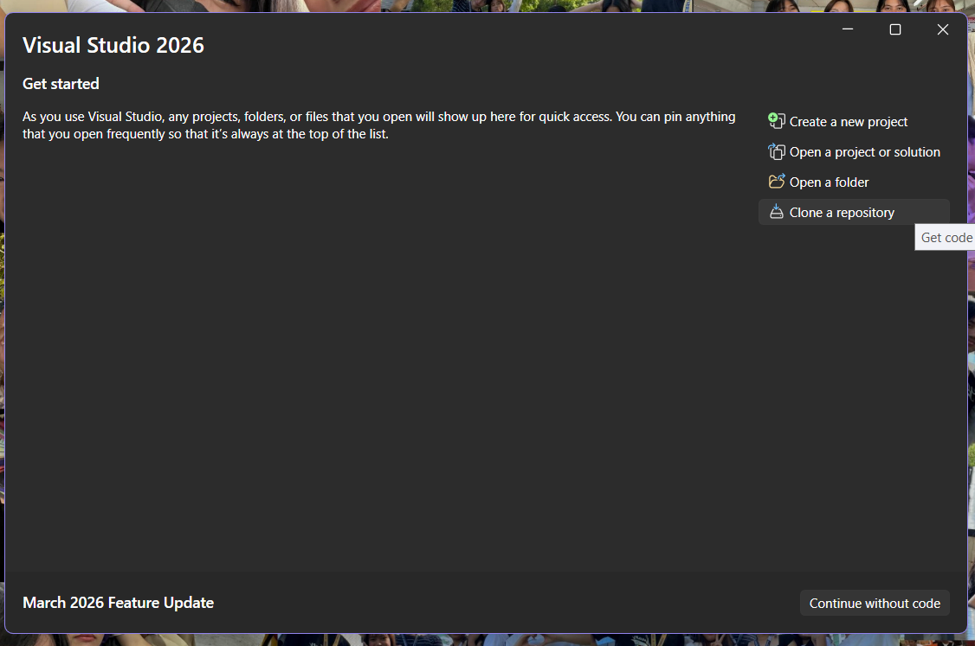
- Copy the HTTPS Link from GitHub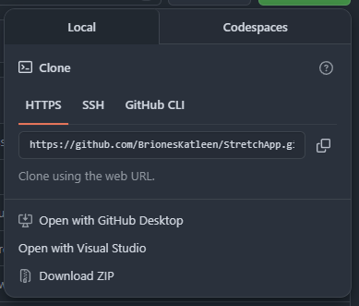
- Go back to MS Visual Studio and paste repository https in the “Repository location”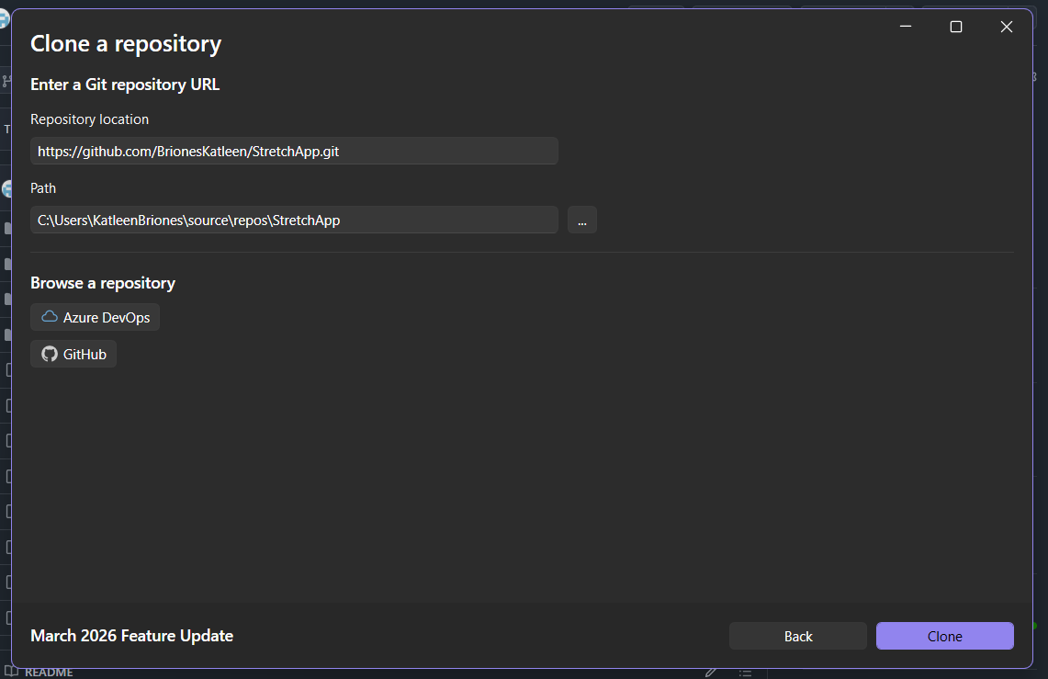
- Wait for it load the repository
- Go to view then click “Terminal”
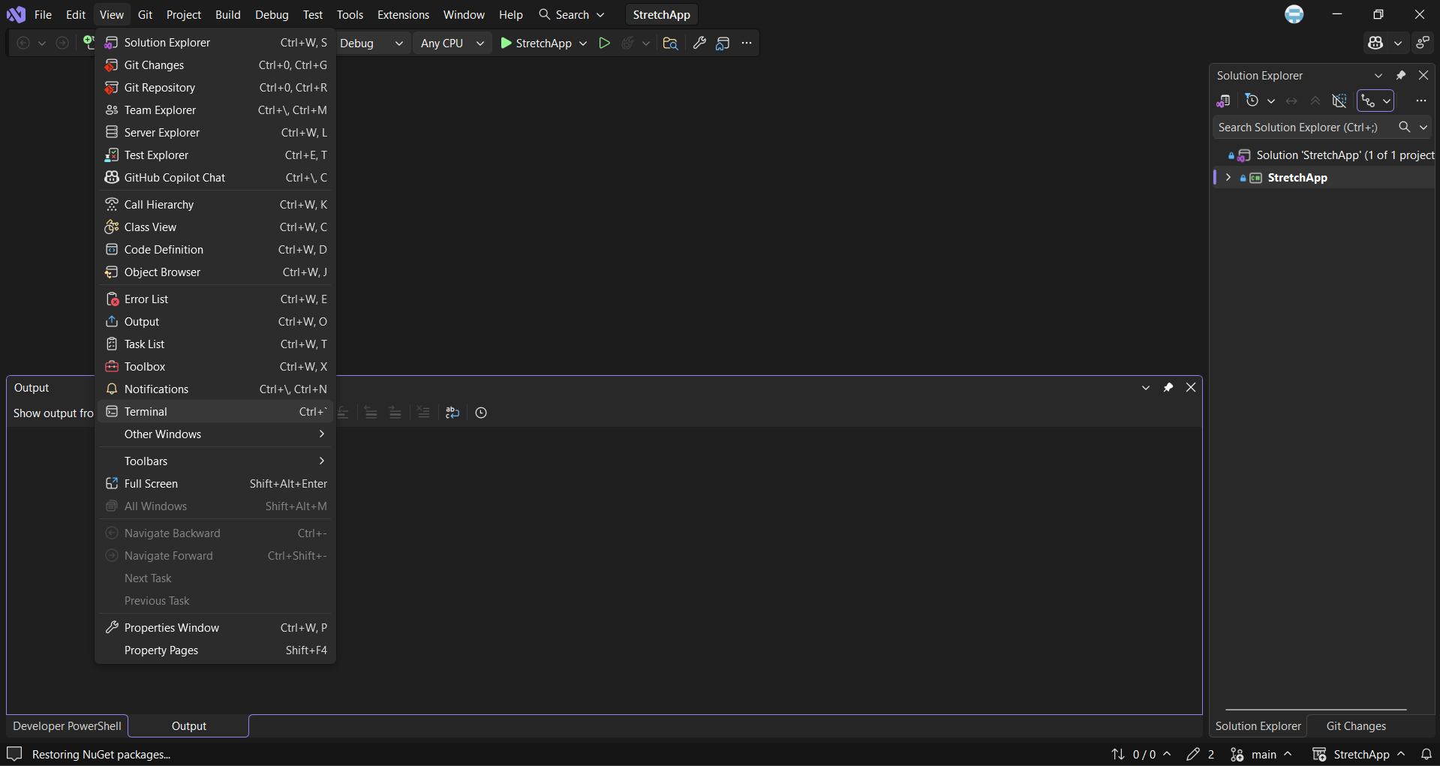

Creating dev branch locally
- Currently dev branch only exists remotely (Github and not in your local computer)
- Check branches locally.
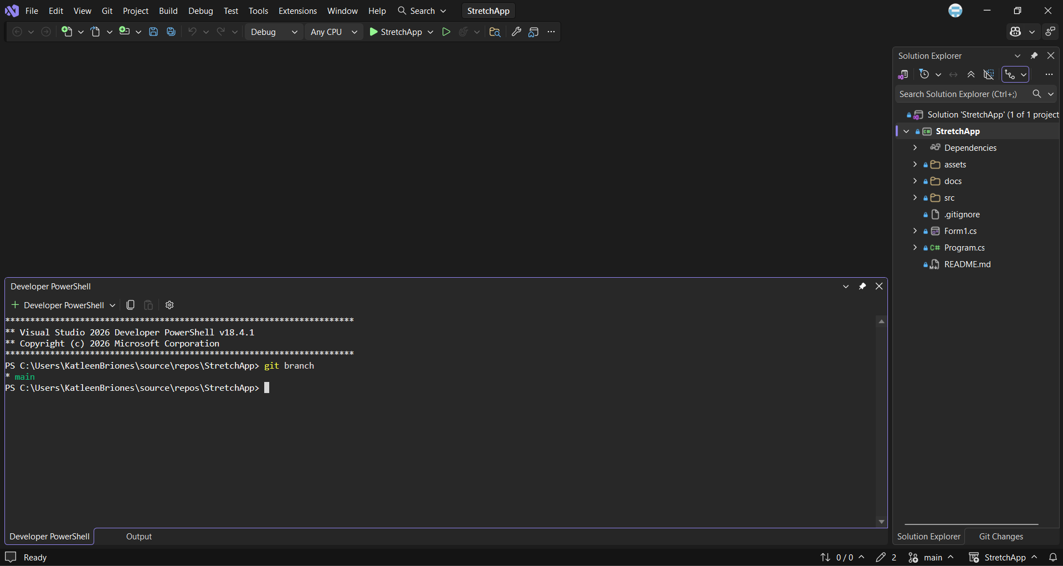
Note: Make sure the file path in the terminal is inside the StretchApp (use cd command if not)
- As you can see above, it only have master branch so create a local branch that tracks an existing remote branch (dev)
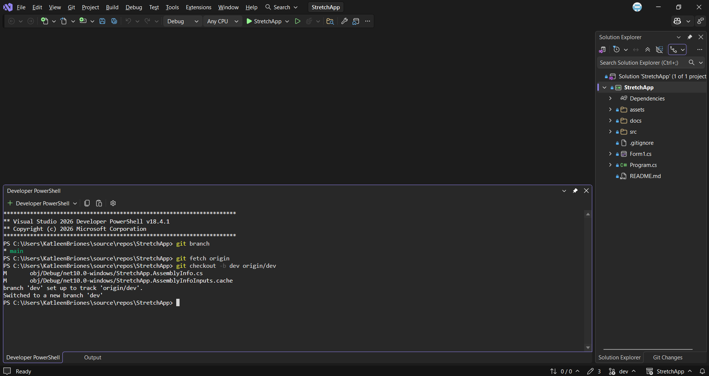
- Check at the Right-bottom conner if the branch had switch from main to dev. If not do this.
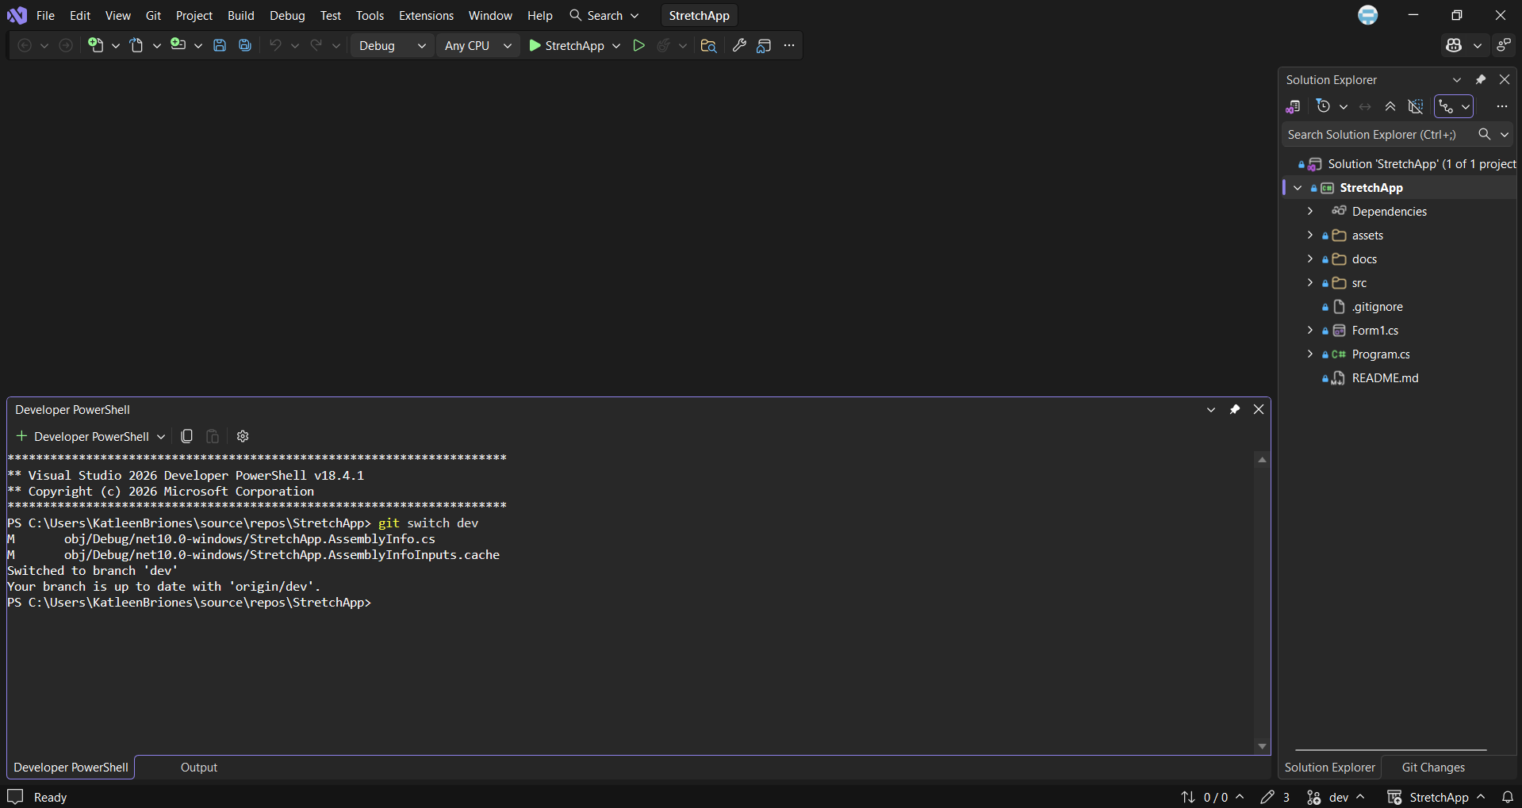
Create a child-branch of dev branch
- Each member must create their own child-branch to work on
- Check if you’re in the dev branch and create a child branch.
- Go to the right-bottom corner click the “main” and you will see all the branches.
- Click “New Branch”
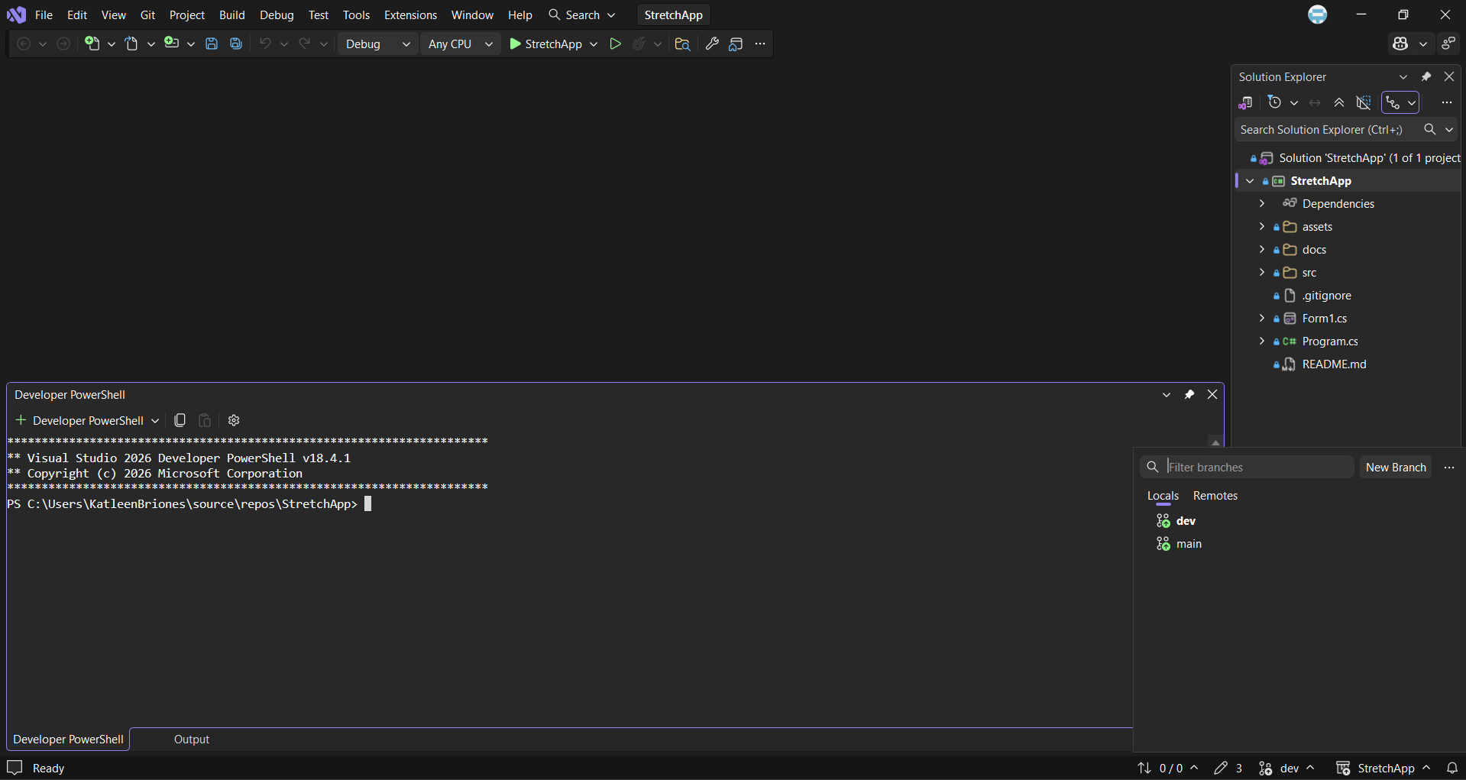
- Create the child-branch of dev
- Make sure the “Based on:” is dev
- Branch name format: feature/[feature-type]
- Example: feature/pomodoro-timer
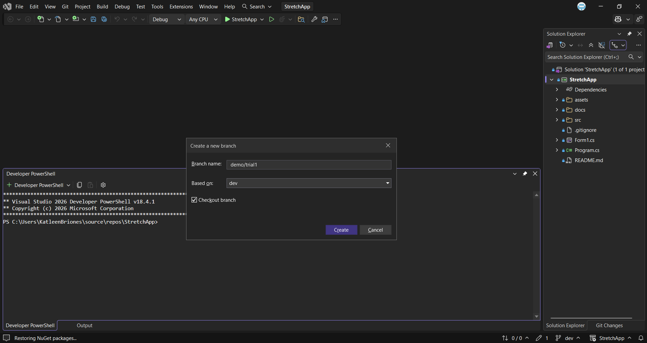
- You successfully create a child-branch locally.
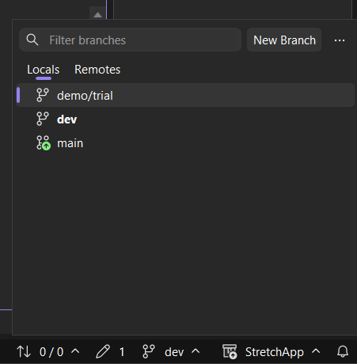
- Be sure to switch from dev or main branch to your respective branch (like demo/trial) After then you can start your work inside your branch.
- Commit changes only to your branch not in the main or dev branch.
- If your done and want others to check it, Open Pull Request to dev branch and wait for the TechLead or at least 2 members to check your PR before pushing to dev branch.
- If issues are created, solve it before pushing or closing the PR. PR should only close after the issue has been closed.

